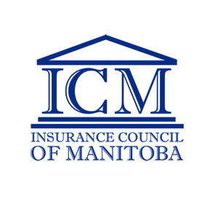

Certificate of Authority Request Form /
Non-Resident Endorsement Request Form

**This form is to be completed by an agent who currently resides in Manitoba and wishes to obtain a licence in another jurisdiction**

- Name of Applicant:
Last First Middle

- Residence Address:
Mailing Address (Street, Box, R.R., Site)

City Province Postal Code

3.) Name of Agency and/or Sponsor:

4.) Manitoba Business Address:
Street/Box/R.R./Site City, Province

Postal Code Business Telephone Alternate Phone

5.) Requested Province(s) or State(s):

6.) Email Address to send the Certificate(s) to:
*The Certificate(s) will be emailed to you once prepared. Hard Copies are no longer provided.

Signature Date

DO NOT WRITE BELOW THIS LINE

User ID Cheques are made payable to the: Certificate Fee = $70.00

Insurance Council of Manitoba

(Must be in Canadian funds)

