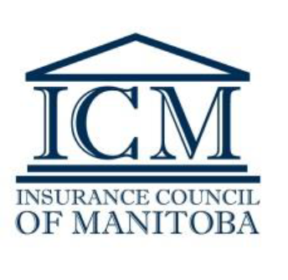

**Manitoba Operating Agent Attestation**

**COVID-19**

**General Level 1 Insurance Agent - Work from Home Restrictions**

*Created Nov 18/20*

*The below Attestation is required from all Operating Agents if you have, or plan to have, Level 1 General Agents licensed in Manitoba working from home. Failure to file a signed copy with the ICM will delay the issuance of a General Level 1 Insurance Agent Licence.*

Communication sent to all Operating Agents:

As you know, under Manitoba’s General Insurance Licensing Rules, Level 1 general agents are required to work inside the office of a general insurance agency and under the supervision of a Level 2 or 3 licence holder. Recognizing work from home plans and protocols being put in place by agencies to meet public health recommendations arising from COVID-19, the following plan has been made to assist industry with business continuity.

The Superintendent of Financial Institutions has approved that the requirement for Level 1 general licence holders to only work inside the office of a general insurance agency **will be suspended up to and including March 31st, 2021, with restrictions as outlined below, and with the Operating Agent completing and submitting this Attestation form to the ICM, confirming that your agency will abide by these restrictions.**

As the Operating Agent for the agency named below, I confirm that until end of day March 31, 2021:

* The agency has an appropriate supervision plan in place for all **Level 1 general agents** working from home;
* Although the supervision plan is not required to be filed with the ICM, ICM may at any reasonable time request and be provided with a written copy of the supervision plan;
* The business activity of the **Level 1 general agents** working from home will be restricted to processing renewals that do not have any amendments to coverage;
* Any changes to coverages or remarketing of policies for Manitoba clients will be referred to a Level 2 or Level 3 agent for action, and will not be completed by a **Level 1 general agent** working from home without first having been reviewed **and** approved by a Level 2 or Level 3 agent; and
* With respect only to Manitoba Public Insurance (MPI) auto transactions with no SRE, a Level 1 licence holder working from home may make coverage changes on the MPI policy as long as the Level 1 licence holder has consistent and immediate access to communicate with a Level 2 or 3 licence holder if required.

**Agency Name**

     

**Printed Name of Operating Agent/Broker Level 3 attesting to the above** **User ID**

     

**Signature of Operating Agent/Broker Level 3 attesting to the above** **Date**

*Electronic signatures are accepted*

***Additional ‘News and Bulletins’ relating to licensing matters, and any change in the above circumstances, can be found on your Dashboard when logged into the*** [***ICM Online Portal***](https://lms.icm.mb.ca/IcmPortal/Account/Login?ReturnUrl=%2fIcmPortal%2fHome%2fError%3faspxerrorpath%3d%2fIcmPortal%2fAccount%2f&aspxerrorpath=/IcmPortal/Account/)***. COVID-19 related*** [***FAQs***](https://icm.mb.ca/files/Licensing%20Info/COVID-19_FAQs_March_24_2020.pdf) ***are also posted on the ICM website and within ‘News and Bulletins’. Check the Portal and website regularly for updates.***

**INSURANCE COUNCIL OF MANITOBA**[contactus@icm.mb.ca](mailto:contactus@icm.mb.ca) [www.icm.mb.ca](http://www.icm.mb.ca)